[](https://ida.interchain.io/)

[Interchain Developer Academy](https://ida.interchain.io/)/[Interchain Developer Academy](https://ida.interchain.io/academy/3-ibc/12-ibc-tooling.html)



Search

[Interchain Developer Academy](https://ida.interchain.io/)[Interchain Developer Academy](https://ida.interchain.io/academy/3-ibc/12-ibc-tooling.html)

Search



Filters

Interchain Developer Academy

[](https://ida.interchain.io/academy/3-ibc/12-ibc-tooling.html)

[Week 0 - Getting Started](https://ida.interchain.io/academy/3-ibc/12-ibc-tooling.html)

[Getting Started](https://ida.interchain.io/academy/3-ibc/12-ibc-tooling.html)

[Blockchain 101](https://ida.interchain.io/academy/3-ibc/12-ibc-tooling.html)

[Blockchain History](https://ida.interchain.io/academy/3-ibc/12-ibc-tooling.html)

[Public and Managed Blockchains](https://ida.interchain.io/academy/3-ibc/12-ibc-tooling.html)

[Consensus in Distributed Networks](https://ida.interchain.io/academy/3-ibc/12-ibc-tooling.html)

[Cryptography](https://ida.interchain.io/academy/3-ibc/12-ibc-tooling.html)

[Self-Assessment Quiz](https://ida.interchain.io/academy/3-ibc/12-ibc-tooling.html)

[Go Introduction - First Steps](https://ida.interchain.io/academy/3-ibc/12-ibc-tooling.html)

[Go Basics](https://ida.interchain.io/academy/3-ibc/12-ibc-tooling.html)

[Go Interfaces](https://ida.interchain.io/academy/3-ibc/12-ibc-tooling.html)

[Control Structures in Go](https://ida.interchain.io/academy/3-ibc/12-ibc-tooling.html)

[Arrays and Slices in Go](https://ida.interchain.io/academy/3-ibc/12-ibc-tooling.html)

[Standard Packages in Go](https://ida.interchain.io/academy/3-ibc/12-ibc-tooling.html)

[Concurrency in Go](https://ida.interchain.io/academy/3-ibc/12-ibc-tooling.html)

[Good-To-Know Dev Terms](https://ida.interchain.io/academy/3-ibc/12-ibc-tooling.html)

[Docker Introduction](https://ida.interchain.io/academy/3-ibc/12-ibc-tooling.html)

[](https://ida.interchain.io/academy/3-ibc/12-ibc-tooling.html)

[Week 1 - Introduction to the Interchain](https://ida.interchain.io/academy/3-ibc/12-ibc-tooling.html)

[Introduction to the Interchain](https://ida.interchain.io/academy/3-ibc/12-ibc-tooling.html)

[Blockchain Technology and the Interchain](https://ida.interchain.io/academy/3-ibc/12-ibc-tooling.html)

[The Interchain Ecosystem](https://ida.interchain.io/academy/3-ibc/12-ibc-tooling.html)

[Getting ATOM and Staking It](https://ida.interchain.io/academy/3-ibc/12-ibc-tooling.html)

[A Blockchain App Architecture](https://ida.interchain.io/academy/3-ibc/12-ibc-tooling.html)

[Accounts](https://ida.interchain.io/academy/3-ibc/12-ibc-tooling.html)

[Transactions](https://ida.interchain.io/academy/3-ibc/12-ibc-tooling.html)

[Messages](https://ida.interchain.io/academy/3-ibc/12-ibc-tooling.html)

[Modules](https://ida.interchain.io/academy/3-ibc/12-ibc-tooling.html)

[Protobuf](https://ida.interchain.io/academy/3-ibc/12-ibc-tooling.html)

[Multistore and Keepers](https://ida.interchain.io/academy/3-ibc/12-ibc-tooling.html)

[BaseApp](https://ida.interchain.io/academy/3-ibc/12-ibc-tooling.html)

[Queries](https://ida.interchain.io/academy/3-ibc/12-ibc-tooling.html)

[Events](https://ida.interchain.io/academy/3-ibc/12-ibc-tooling.html)

[Context](https://ida.interchain.io/academy/3-ibc/12-ibc-tooling.html)

[Testing](https://ida.interchain.io/academy/3-ibc/12-ibc-tooling.html)

[Relaying with IBC](https://ida.interchain.io/academy/3-ibc/12-ibc-tooling.html)

[Interchain Security](https://ida.interchain.io/academy/3-ibc/12-ibc-tooling.html)

[Bridges](https://ida.interchain.io/academy/3-ibc/12-ibc-tooling.html)

[Migrations](https://ida.interchain.io/academy/3-ibc/12-ibc-tooling.html)

[Week 1 Quiz](https://ida.interchain.io/academy/3-ibc/12-ibc-tooling.html)

[](https://ida.interchain.io/academy/3-ibc/12-ibc-tooling.html)

[Week 2 - First Steps](https://ida.interchain.io/academy/3-ibc/12-ibc-tooling.html)

[First Steps](https://ida.interchain.io/academy/3-ibc/12-ibc-tooling.html)

[Setup Your Work Environment](https://ida.interchain.io/academy/3-ibc/12-ibc-tooling.html)

[Run a Node, API, and CLI](https://ida.interchain.io/academy/3-ibc/12-ibc-tooling.html)

[Ignite CLI](https://ida.interchain.io/academy/3-ibc/12-ibc-tooling.html)

[Exercise - Make a Checkers Blockchain](https://ida.interchain.io/academy/3-ibc/12-ibc-tooling.html)

[Store Object](https://ida.interchain.io/academy/3-ibc/12-ibc-tooling.html)

[Create Custom Messages](https://ida.interchain.io/academy/3-ibc/12-ibc-tooling.html)

[Create and Save a Game Properly](https://ida.interchain.io/academy/3-ibc/12-ibc-tooling.html)

[Add a Way to Make a Move](https://ida.interchain.io/academy/3-ibc/12-ibc-tooling.html)

[Emit Game Information](https://ida.interchain.io/academy/3-ibc/12-ibc-tooling.html)

[Record the Game Winner](https://ida.interchain.io/academy/3-ibc/12-ibc-tooling.html)

[Week 2 Exercise](https://ida.interchain.io/academy/3-ibc/12-ibc-tooling.html)

[](https://ida.interchain.io/academy/3-ibc/12-ibc-tooling.html)

[Week 3 - Introduction to IBC and CosmJS](https://ida.interchain.io/academy/3-ibc/12-ibc-tooling.html)

[Introduction to IBC and CosmJS](https://ida.interchain.io/academy/3-ibc/12-ibc-tooling.html)

[What is IBC?](https://ida.interchain.io/academy/3-ibc/12-ibc-tooling.html)

[IBC/TAO - Connections (OPTIONAL)](https://ida.interchain.io/academy/3-ibc/12-ibc-tooling.html)

[IBC/TAO - Channels (OPTIONAL)](https://ida.interchain.io/academy/3-ibc/12-ibc-tooling.html)

[IBC/TAO - Clients (OPTIONAL)](https://ida.interchain.io/academy/3-ibc/12-ibc-tooling.html)

[IBC Token Transfer](https://ida.interchain.io/academy/3-ibc/12-ibc-tooling.html)

[Interchain Accounts (OPTIONAL)](https://ida.interchain.io/academy/3-ibc/12-ibc-tooling.html)

[IBC Middleware (OPTIONAL)](https://ida.interchain.io/academy/3-ibc/12-ibc-tooling.html)

[Create a Custom IBC Middleware (OPTIONAL)](https://ida.interchain.io/academy/3-ibc/12-ibc-tooling.html)

[Integrate IBC Middleware Into a Chain (OPTIONAL)](https://ida.interchain.io/academy/3-ibc/12-ibc-tooling.html)

[IBC Tooling](https://ida.interchain.io/academy/3-ibc/12-ibc-tooling.html)

[What is CosmJS?](https://ida.interchain.io/academy/3-ibc/12-ibc-tooling.html)

[Your First CosmJS Actions](https://ida.interchain.io/academy/3-ibc/12-ibc-tooling.html)

[Compose Complex Transactions](https://ida.interchain.io/academy/3-ibc/12-ibc-tooling.html)

[Learn to Integrate Keplr](https://ida.interchain.io/academy/3-ibc/12-ibc-tooling.html)

[Create Custom CosmJS Interfaces](https://ida.interchain.io/academy/3-ibc/12-ibc-tooling.html)

[](https://ida.interchain.io/academy/3-ibc/12-ibc-tooling.html)

[Week 4 - Ignite CLI and IBC Advanced](https://ida.interchain.io/academy/3-ibc/12-ibc-tooling.html)

[Ignite CLI and IBC Advanced](https://ida.interchain.io/academy/3-ibc/12-ibc-tooling.html)

[Keep an Up-To-Date Game Deadline](https://ida.interchain.io/academy/3-ibc/12-ibc-tooling.html)

[Keep Track Of How Many Moves Have Been Played](https://ida.interchain.io/academy/3-ibc/12-ibc-tooling.html)

[Put Your Games in Order](https://ida.interchain.io/academy/3-ibc/12-ibc-tooling.html)

[Auto-Expiring Games](https://ida.interchain.io/academy/3-ibc/12-ibc-tooling.html)

[Let Players Set a Wager](https://ida.interchain.io/academy/3-ibc/12-ibc-tooling.html)

[Handle wager payments](https://ida.interchain.io/academy/3-ibc/12-ibc-tooling.html)

[Integration tests](https://ida.interchain.io/academy/3-ibc/12-ibc-tooling.html)

[Incentivize Players](https://ida.interchain.io/academy/3-ibc/12-ibc-tooling.html)

[Help Find a Correct Move](https://ida.interchain.io/academy/3-ibc/12-ibc-tooling.html)

[Play With Cross-Chain Tokens](https://ida.interchain.io/academy/3-ibc/12-ibc-tooling.html)

[Understand IBC Denoms](https://ida.interchain.io/academy/3-ibc/12-ibc-tooling.html)

[Go Relayer](https://ida.interchain.io/academy/3-ibc/12-ibc-tooling.html)

[Hermes Relayer](https://ida.interchain.io/academy/3-ibc/12-ibc-tooling.html)

[](https://ida.interchain.io/academy/3-ibc/12-ibc-tooling.html)

[Week 5 - CosmJS Advanced](https://ida.interchain.io/academy/3-ibc/12-ibc-tooling.html)

[CosmJS Advanced](https://ida.interchain.io/academy/3-ibc/12-ibc-tooling.html)

[Create Custom Objects](https://ida.interchain.io/academy/3-ibc/12-ibc-tooling.html)

[Create Custom Messages](https://ida.interchain.io/academy/3-ibc/12-ibc-tooling.html)

[Get an External GUI](https://ida.interchain.io/academy/3-ibc/12-ibc-tooling.html)

[Integrate CosmJS and Keplr](https://ida.interchain.io/academy/3-ibc/12-ibc-tooling.html)

[Backend Script for Game Indexing](https://ida.interchain.io/academy/3-ibc/12-ibc-tooling.html)

[](https://ida.interchain.io/academy/3-ibc/12-ibc-tooling.html)

[Week 6 - IBC Deep Dive](https://ida.interchain.io/academy/3-ibc/12-ibc-tooling.html)

[IBC Deep Dive](https://ida.interchain.io/academy/3-ibc/12-ibc-tooling.html)

[IBC Application Developer Introduction](https://ida.interchain.io/academy/3-ibc/12-ibc-tooling.html)

[Make a Module IBC-Enabled](https://ida.interchain.io/academy/3-ibc/12-ibc-tooling.html)

[Adding Packet and Acknowledgment Data](https://ida.interchain.io/academy/3-ibc/12-ibc-tooling.html)

[Extend the Checkers Game With a Leaderboard](https://ida.interchain.io/academy/3-ibc/12-ibc-tooling.html)

[Create a Leaderboard Chain](https://ida.interchain.io/academy/3-ibc/12-ibc-tooling.html)

[](https://ida.interchain.io/academy/3-ibc/12-ibc-tooling.html)

[Week 7 - From Code to MVP to Production and Migrations](https://ida.interchain.io/academy/3-ibc/12-ibc-tooling.html)

[From Code to MVP to Production and Migrations](https://ida.interchain.io/academy/3-ibc/12-ibc-tooling.html)

[Run in Production](https://ida.interchain.io/academy/3-ibc/12-ibc-tooling.html)

[Prepare the Software to Run](https://ida.interchain.io/academy/3-ibc/12-ibc-tooling.html)

[Prepare a Validator and Keys](https://ida.interchain.io/academy/3-ibc/12-ibc-tooling.html)

[Prepare Where the Node Starts](https://ida.interchain.io/academy/3-ibc/12-ibc-tooling.html)

[Prepare and Connect to Other Nodes](https://ida.interchain.io/academy/3-ibc/12-ibc-tooling.html)

[Configure, Run, and Set Up a Service](https://ida.interchain.io/academy/3-ibc/12-ibc-tooling.html)

[Prepare and Do Migrations](https://ida.interchain.io/academy/3-ibc/12-ibc-tooling.html)

[Simulate Production in Docker](https://ida.interchain.io/academy/3-ibc/12-ibc-tooling.html)

[Tally Player Info After Production](https://ida.interchain.io/academy/3-ibc/12-ibc-tooling.html)

[Add a Leaderboard as a Module](https://ida.interchain.io/academy/3-ibc/12-ibc-tooling.html)

[Migrate the Leaderboard Module After Production](https://ida.interchain.io/academy/3-ibc/12-ibc-tooling.html)

[Simulate a Migration in Docker](https://ida.interchain.io/academy/3-ibc/12-ibc-tooling.html)

[Final Exam](https://ida.interchain.io/academy/3-ibc/12-ibc-tooling.html)

[](https://ida.interchain.io/academy/3-ibc/12-ibc-tooling.html)

[What's Next?](https://ida.interchain.io/academy/3-ibc/12-ibc-tooling.html)

[Continue Your Interchain Journey](https://ida.interchain.io/academy/3-ibc/12-ibc-tooling.html)

Docs Version Switcher

On this page

[MapOfZones - explore the Interchain network](https://ida.interchain.io/academy/3-ibc/12-ibc-tooling.html#mapofzones-explore-the-interchain-network)

[Mintscan](https://ida.interchain.io/academy/3-ibc/12-ibc-tooling.html#mintscan)

[IOBScan](https://ida.interchain.io/academy/3-ibc/12-ibc-tooling.html#iobscan)

[#Copy link](https://ida.interchain.io/academy/3-ibc/12-ibc-tooling.html#ibc-tooling) **IBC Tooling**



In this section, you will discover the following tools:

* MapOfZones
* Mintscan
* IOBScan

In this section, you will take a look at three very helpful visualization tools for the IBC network. They include information on the chains in the network (hub and zones), connections, channels, and transactions.

While going through the overview, it is recommended to try out all there is to discover: just click around and see what happens.

These types of tools help maintain an overview of the overall IBC network, but can also assist with things like relayer selection, as they provide an overview of essential metrics when it comes to relaying.

[#Copy link](https://ida.interchain.io/academy/3-ibc/12-ibc-tooling.html#mapofzones-explore-the-interchain-network) MapOfZones - explore the Interchain network

[MapOfZones (opens new window)↗](https://mapofzones.com/) is an Interchain network explorer.

By default, the explorer shows you a visual overview of the IBC network for the last 24 hours:

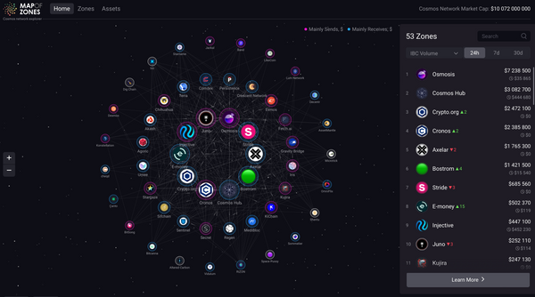

You can also change the time being visualized by the MapOfZones in the lower right side of the display. You can choose between:

* 24 hours
* Seven days
* 30 days

The overview is dynamic and gives you a good feeling of the current activity in the overall network and between specific chains.

The individual chains are visualized by circle icons, sometimes including the chain's logo. Additionally, you can see connecting lines between the different chains. These lines represent connections between chains.

When you click on a specific chain with your mouse cursor, an overview of data for that chain is displayed on the right side.

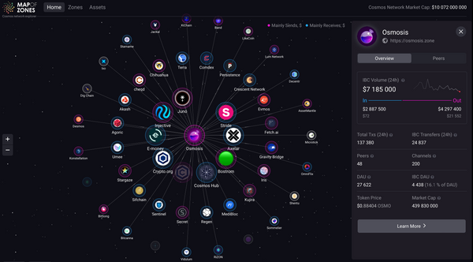

The information displayed includes:

* The number of transactions on that chain (for the selected time period)
* The number of IBC transfers (for the selected time period)
* The number of peers
* The number of channels
* A button for more Learn more

If you click on the Learn more, you are directed to an overview with more in-depth information about the chain selected:

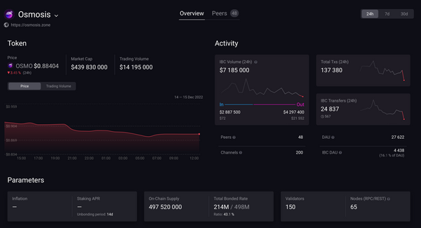

In the peers section, you can find a list of all the chains the selected chain is connected to. When you click on a specific chain, you can see the channels between the selected chain and another chain:

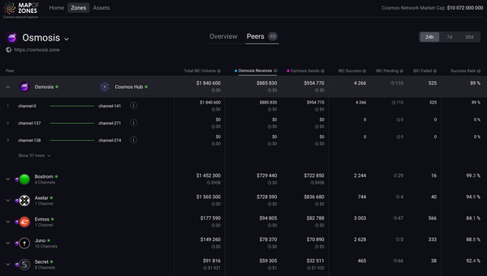

Now you have an overview for each channel, including: how much IBC volume is transferred between the chains through the individual channels; the number of transfers successfully transferred to and received from a particular zone; the balancing figure between inbound and outbound IBC transfers; the number of IBC transfers failed attributed to a particular pair of channels between zones; and the ratio of successfully completed transfers to all transfers with final status.



There are canonical channels for ICS-20. All other channels will have been created accidentally by (inexperienced) relayers and hence have practically no transactions.

When you go to the Zones, you can find a list of the most active zones by IBC volume in USD:

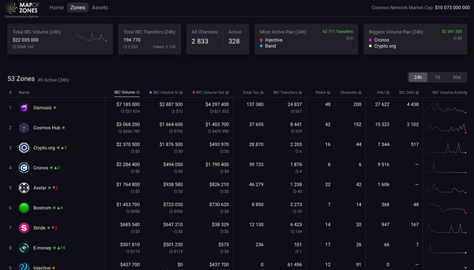

The list includes very useful information, such as:

* IBC volume, $: USD value of tokens successfully relayed via IBC transfer with pertinent volume in progress.
* IBC volume in, $: USD value of tokens successfully received from other zones with pertinent volume in progress.
* IBC volume out, $: USD value of tokens successfully transferred to other zones with pertinent volume in progress.
* IBC transfer: number of successfully relayed IBC transfers with pertinent quantity in progress.
* IBC DAU: number of unique addresses within the zone that have initiated outward IBC transfers.

You can also sort the list in either ascending or descending order with a click on the label.

[#Copy link](https://ida.interchain.io/academy/3-ibc/12-ibc-tooling.html#mintscan) Mintscan

[Mintscan (opens new window)↗](https://hub.mintscan.io/) is another Interchain network explorer.

It gives an overview of IBC networks, including a visualization (left side) and a list (right side). For the former, the default is set to give you a visualization based on IBC transactions within a 30-day period:

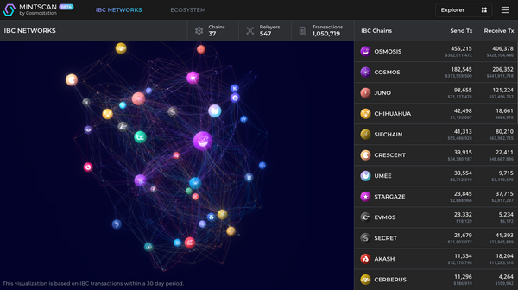

To select a specific chain, just click on it in the visualization. You will get a display of more detailed information for that chain:

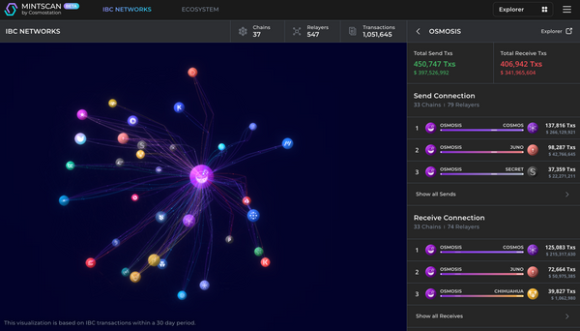

Here you can see:

* The total of send transactions measured in transactions and USD - Total Send Txs.
* The total of receive transactions measured in transactions and USD - Total Receive Txs.
* The send connection, with the number of chains and relayers.
* The receive connection, with the number of chains and relayers.

You can also click on Show all Sends and Show all Receives to get a complete list for both.

Scroll down:

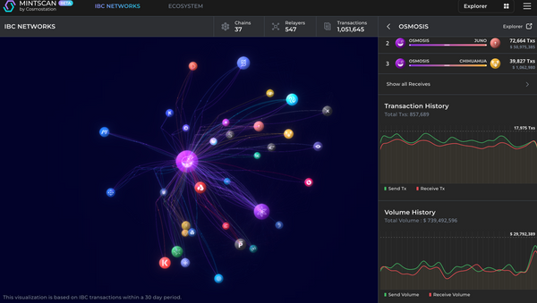

Here you can see graphs for:

* The **transaction history**, with information on the total transactions, amount of send transactions, and amount of receive transactions.
* The **volume history**, with information on the total transaction volume, send volume, and receive volume.

You can also use the list on the right-hand side to select a specific blockchain and get a detailed information overview for that chain:

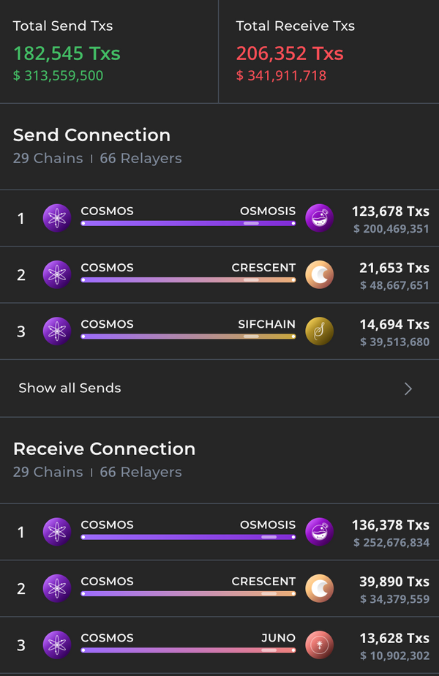

In the detailed overview you can select a specific connection, and Mintscan will show you the corresponding channels:

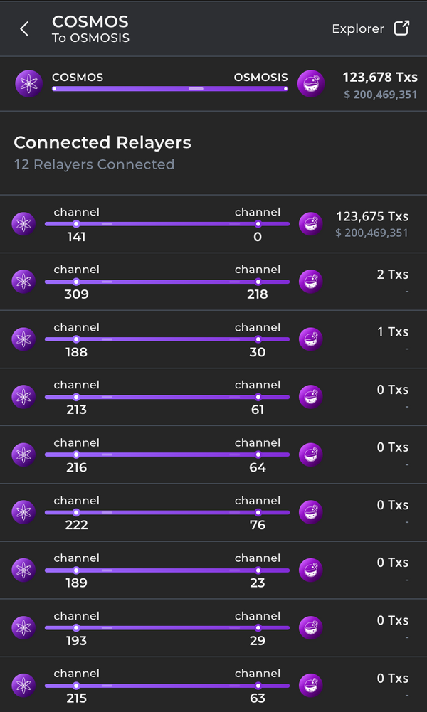

If you click one of the connections you can see the connections, send and receive transactions, the relayer transaction history, and the relayer volume history:

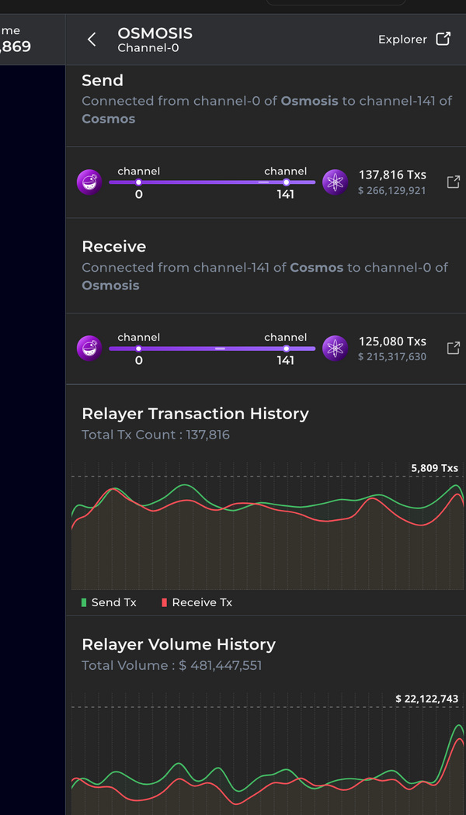

If you select a channel, you will be forwarded to a page with more in-depth information regarding that IBC relayer:

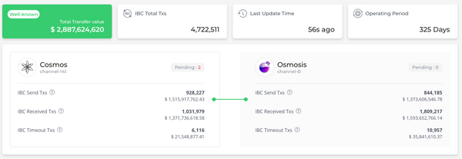

Among other things you can find out:

* If a relayer is well known
* The total transfer value for the relayer
* The last time an update was done
* The operating period for that IBC relayer

Below that you will find an overview of the weekly transferred values of receive and send transactions:

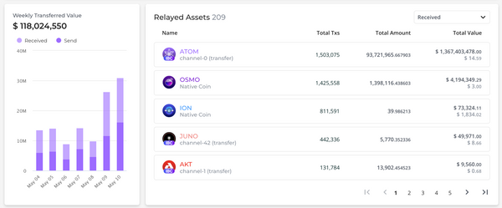

You can also look into the relayer operators - operator address, IBC received transactions, and the date and time of the last update are displayed:

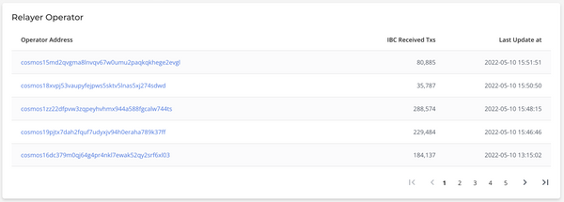

At the end of the page, you can find a list of all transactions:

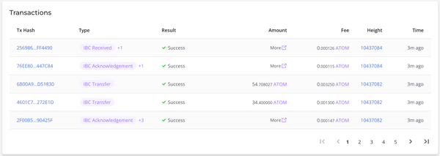

The list of transactions includes information on:

* The transaction's hash
* The type of transaction
* The result - was it successful?
* The amount transferred
* The fee of the transaction
* The transaction's height
* How long ago a transaction was conducted

When you click on a specific transaction in the list, you are forwarded to a page with the transaction details.

For example, click on a transaction marked as an **IBC transfer** (in the type column of the transaction list):

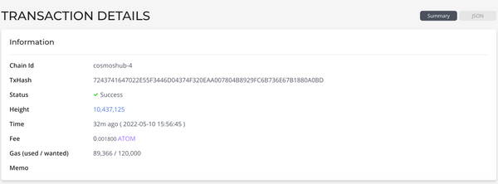

This gives you an overview of the transaction, which includes:

* Chain ID
* Transaction hash
* Status of the transaction
* Height of the transaction
* Time of the transaction
* Fee for the transaction
* Gas used and wanted
* Memo

Further below, you can also look into information on the messages involved. Next to a lot of information on the message, you can also look into the IBC progress of IBC acknowledgements:

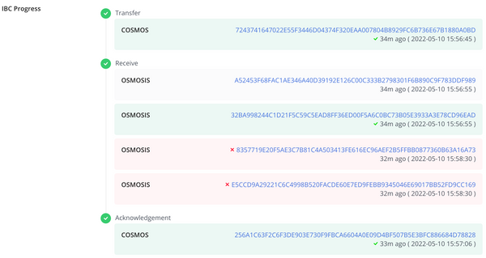

[#Copy link](https://ida.interchain.io/academy/3-ibc/12-ibc-tooling.html#iobscan) IOBScan

Now, turn your focus to another blockchain explorer, [IOBScan (opens new window)↗](https://ibc.iobscan.io/home).

From the IOBScan homepage you can get a quick overview of networks, channels, IBC token transfers, and IBC tokens:

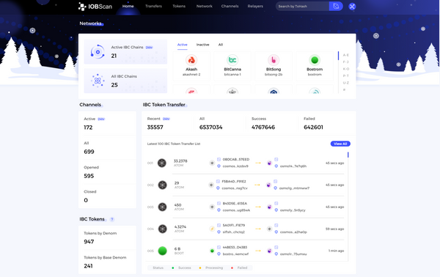

You can use the tab navigation for a closer look at:

* Transfers
* Tokens
* The network
* Channels
* Relayers

A search functionality by transaction hash is possible too.

In the upper-right-hand corner, you can select the network. For example, you can switch between the mainnet of Iris Hub, the mainnet of the Cosmos Hub, the Stargate testnet, and the Nyancat testnet.

On the right-hand side (next to the visualization) you can find a list of all networks, sorted by either connections or chains.



If you want a visualization of the network, just click on the network icon in the upper-right-hand corner. This redirects you to the [IOBSCAN Network State Visualizer (opens new window)↗](https://www.iobscan.io/#/):

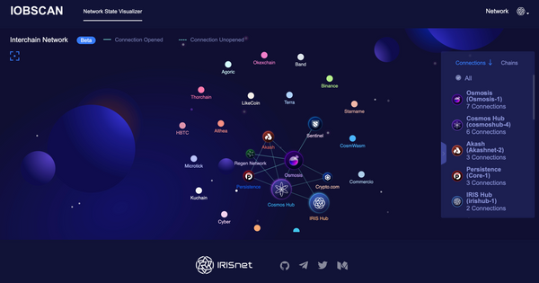

The connections displayed in the visualizer have either a regular or a dotted line, depending on whether a connection is opened or unopened.

synopsis

To summarize, this section has explored:

* **MapOfZones**, a network explorer for the Interchain Ecosystem, which provides a variety of dynamic visualizations of network activity over time, allowing easy comprehension of transactions occurring between specific individual chains, access to detailed traffic data and in-depth information about chains, and useful information regarding the most active zones by IBC volume in USD.
* **Mintscan**, another Interchain network explorer, which provides an overview of IBC network activity over time, and can focus in on specific chains to show their total transactions (measured in transactions and USD) and connections (with the number of chains and relayers), also providing graphs for transaction and volume history, and can provide highly detailed breakdowns of data at various levels of network detail.
* **IOBScan**, another blockchain explorer, which provides a quick overview of networks, channels, IBC token transfers, and IBC tokens from its homepage; it allows for searching by transaction hash, and also offers the IOBSCAN Network State Visualizer for an alternative high level presentation of connection data between chains.

previous

[](https://ida.interchain.io/academy/3-ibc/11-ibc-mw-integrate.html)

**[Integrate IBC Middleware Into a Chain (OPTIONAL)](https://ida.interchain.io/academy/3-ibc/11-ibc-mw-integrate.html)**

up next

**[What is CosmJS?](https://ida.interchain.io/tutorials/7-cosmjs/1-cosmjs-intro.html)**

[[](https://ida.interchain.io/tutorials/7-cosmjs/1-cosmjs-intro.html)](https://ida.interchain.io/tutorials/7-cosmjs/1-cosmjs-intro.html)

Rate this Page

icon smile

icon meh

icon frown

Would you like to add a message?

Submit

Thank you for your Feedback!

[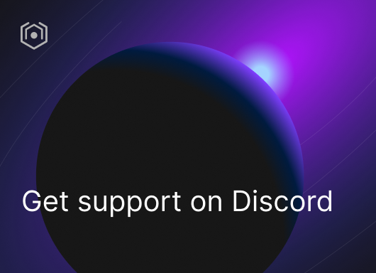](https://ida.interchain.io/ida-course/discord-info.html)

On this page

[MapOfZones - explore the Interchain network](https://ida.interchain.io/academy/3-ibc/12-ibc-tooling.html#mapofzones-explore-the-interchain-network)

[Mintscan](https://ida.interchain.io/academy/3-ibc/12-ibc-tooling.html#mintscan)

[IOBScan](https://ida.interchain.io/academy/3-ibc/12-ibc-tooling.html#iobscan)

#### **Get Cosmos updates**

Unsubscribe at any time. [Privacy Policy↗](https://v1.cosmos.network/privacy)

     Next

Documentation

[Cosmos SDK](https://docs.cosmos.network/)[Cosmos Hub](https://hub.cosmos.network/)[CometBFT](https://docs.cometbft.com/)[IBC Protocol](https://ibc.cosmos.network/)

Community

[Interchain blog](https://blog.cosmos.network/)[Forum](https://forum.cosmos.network/)[Discord](https://discord.gg/cosmosnetwork)

Contributing

[Source code on GitHub](https://github.com/cosmos/sdk-tutorials)

[](https://ida.interchain.io/)

[Interchain Developer Academy](https://ida.interchain.io/)

**[](https://blog.cosmos.network/)[](https://twitter.com/cosmos)[](https://discord.gg/cosmosnetwork)[](https://www.linkedin.com/company/interchain-foundation/about/)[](https://reddit.com/r/cosmosnetwork)[](https://t.me/cosmosproject)[](https://www.youtube.com/c/CosmosProject)**



Dark mode

† This website is maintained by the Interchain Foundation (ICF). The contents and opinions of this website are those of the ICF. The ICF provides links to cryptocurrency exchanges as a service to the public. The ICF does not warrant that the information provided by these websites is correct, complete, and up-to-date. The ICF is not responsible for their content and expressly rejects any liability for damages of any kind resulting from the use, reference to, or reliance on any information contained within these websites.

Cosmos is a registered trademark of the [Interchain Foundation.](https://interchain.io/)[Privacy](https://v1.cosmos.network/privacy)